Assignment 1 Day 4 Lets Upgrade!!!

Que 1)Find out the mail servers of the following domain

1)ibm.com

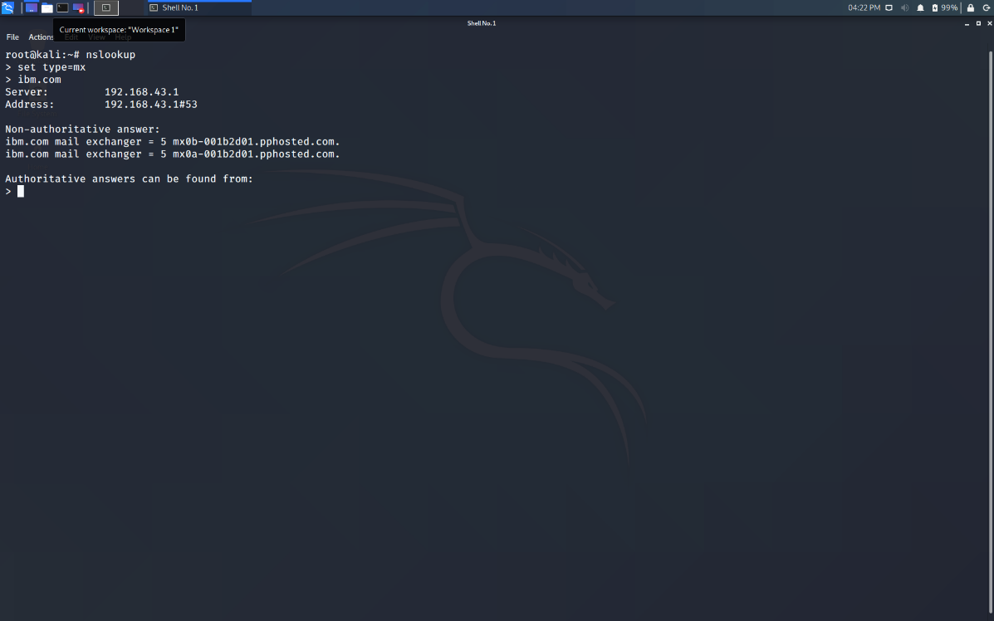

Wipro.com

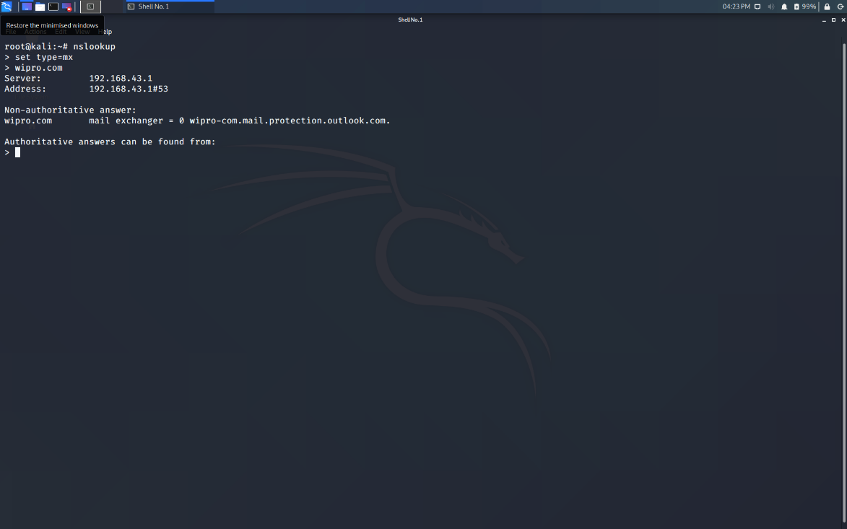

2)Find the locations where the email servers are hosted

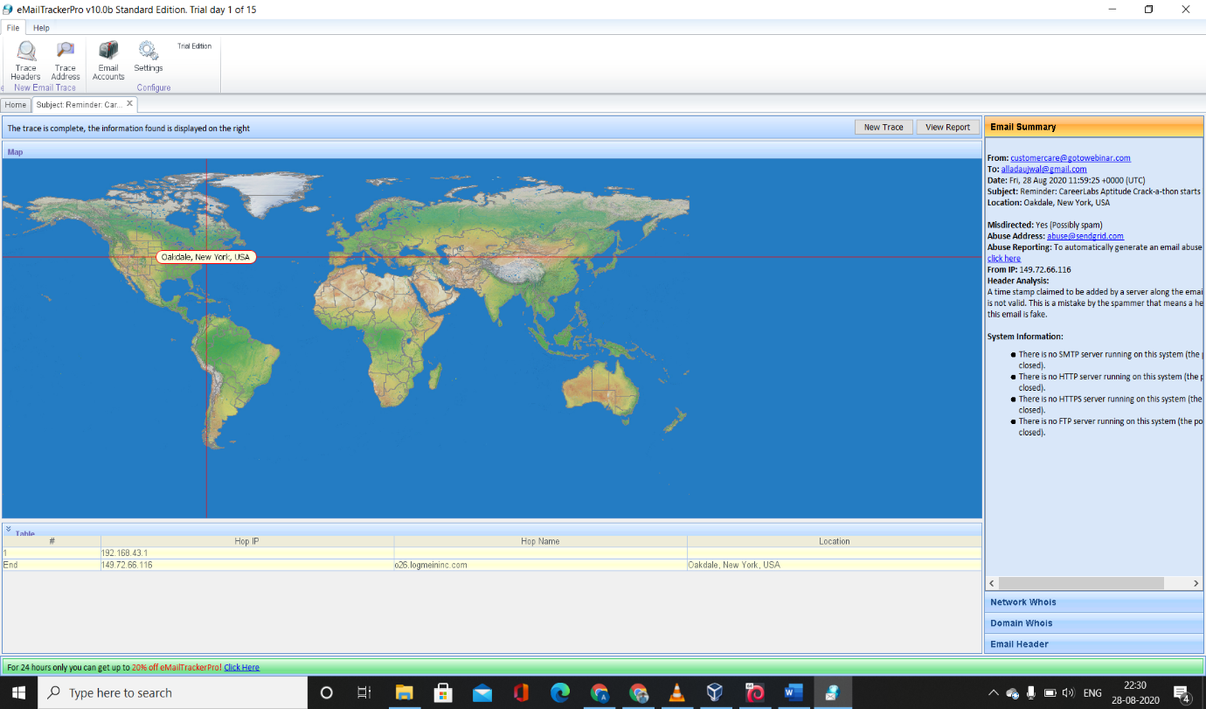

3)Scan and find out the port numbers open 203.163.246.23

